**Wheel Rim Reading Estimation for Customer Material Usage Transactions Functional Requirement**

Wheel readings , consisting of minimum rim thickness, flange height, and flange thickness per key, are received periodically from the customer in a manual format of Excel or CSV files. It may be each quarter or less frequently like twice a year. These manual wheel rim readings need to be cleansed, transformed and loaded into a SQL table for the customer to accumulate this data over time. Each row will have an Equipment Number, an Axle, and a wheel reading Date. These three columns are to be used to join to other data.

A wheel wear rate file will also be received twice a year that needs to be joined to the appropriate wheel rim reading above to be used in an estimation formula given below. These files will need minor clean up and transformation before loading into a separate SQL table. This wear rate table has Road Number ( to join to Equipment Number from wheel rim readings) and an Axle.

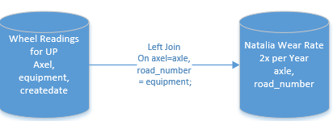

All Material Usage transactions for the customer for a given period of time, let’s work with 1 year for example, needs to have a Wheel Rim Estimation calculated every time we have either a new Wheel Reading file or a Wear Rate file.

All Material Usage transactions need to be retained over this time period in this ETL process and thus Left Joins between Material Usage data and the appropriate Wheel Reading and Wear Rate records found should be used. Below is a diagram showing the Left Join criteria on Axle, Road Number and Dates.

**The Transaction Date from Material Usage should be >= the Wheel Reading Date.**

But there are often multiple matches of wheel readings that satisfies this criteria and the most recent Wheel Reading row is what should be used. There will also be Material Usage transactions where no appropriate wheel readings can be found. These exception cases need to be found and identified as a substitution value will need to be used. We will refer to this dataset as the “GT” records.

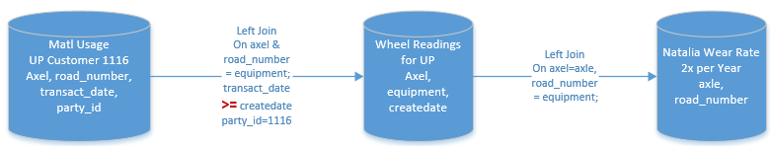

Material Usage transactions matching InCorrect dates as shown below will be referred to as “LT” records.

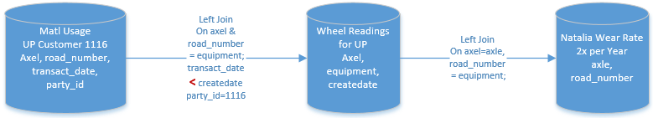

**Basic Wheel Rim Estimation Formula**

Below is the basic logic for estimating a current Wheel Rim Reading if a Wear Rate is found:

**Estimated Rim** = ( Find most current rim thickness reading to match most recent Material Usage transaction –

( Days Interval * Wear Rate found in Wear Rate Table ) )

***Caveat:*** Most Recent Material Usage transaction may not always find a good Wheel Reading Date match!

**Days Interval** = date of material usage transaction - Date of (Most current rim thickness reading found to match)

[  *ELSE use System Run Date as substitution* ]

**Good Date Match Criteria**: Material Usage Transaction Date >= Wheel Rim Reading Date

**Wear Rate** = Find in wear rate table by road number and axle for the correct Wheel Reading matched with most recent Material Usage transaction. The “Usable Rim Rate” column should be used if it is not blank, else, use values from “RIM Rate” instead for each match by Road Number and Axle.

If no wear rate record can be matched with a Wheel Reading by Axle and Road Number, then compute the overall Average RIM Rate for all records in the Wear Rate table where RIM Rate is NOT blank and substitute this as the Wear Rate in the formula above.

**Minim Rim Rule** needed for lower limit of Estimation of Wheel Rims:

If a calculated rim is below 20 inches, then keep reading at 20 inches which equals value of 1.25” in 16ths inch unit.

So any final calculated wheel rim that is < 1.25, use the 1.25 as a replacement minimum rim value.

**Exceptions when a Material Usage Transaction does not have a Wheel Rim Reading match**

When Material Usage transaction has no wheel reading match, either because there is no road number/axle combination to match on, AND/OR, the correct date criteria is not satisfied, then an overall average value needs to be calculated as a substitution.

For all the Material Usage transactions that do have a good wheel reading match, the “GT” dataset, take the group average of this dataset’s wheel rim estimation values and use this as the substitution value above.

